6.72: In Eq. (6.14), 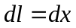 and 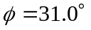 is constant, and so
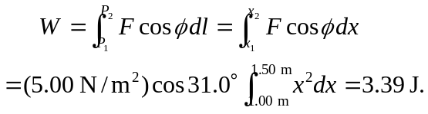
The final speed of the object is then
